Booting Process in Linux
🪛 Step 1: BIOS / UEFI Initialization
When you power on your computer:
- The BIOS (older systems) or UEFI (modern systems) performs a POST (Power-On Self-Test) — checking CPU, RAM, disks, etc.
- It then looks for a bootable device (based on boot order — HDD, SSD, CD, USB, etc.).
- Once found, it loads the first sector (MBR) or EFI partition into memory.
👉 In short: BIOS initializes hardware and locates the boot loader.

Step 2: Boot Loader (GRUB2 Stage)
After BIOS/UEFI finds a bootable device:
- If it’s BIOS + MBR, it loads the first 512 bytes (the Master Boot Record).
- If it’s UEFI + GPT, it loads the GRUB2 EFI file from the EFI System Partition.
Then the boot loader takes over — and on RHEL 9 that’s GRUB2 (GRand Unified Bootloader v2).
GRUB2’s job is to:
- Present a boot menu (you’ve seen it when pressing Esc or Shift during boot).
- Load the Linux kernel (file vmlinuz-...) from /boot.
- Load the initial RAM disk (initramfs) — a temporary root filesystem to start the kernel.
- Pass boot parameters to the kernel (from /etc/default/grub, like rhgb quiet rd.break, etc.).
👉 In short: GRUB2 = middleman between firmware and kernel.

Step 3: Kernel Initialization
Once GRUB has loaded the kernel (vmlinuz) and initramfs into memory, it gives control to the kernel.
Now the real Linux magic starts ✨
When the kernel starts (after GRUB):
1️⃣ Decompresses itself:
The kernel file you see (vmlinuz-…) is a compressed version of the real kernel (vmlinux).
So, first thing it does is unzip itself into memory to get ready to run.
2️⃣ Initializes hardware drivers:
It now starts talking to the CPU, RAM, disks, network cards, etc. — basically making sure all the hardware is ready and drivers are loaded.
3️⃣ Mounts a temporary root filesystem (initramfs):
Because your real disk partitions aren’t ready yet (no / mounted), the kernel uses a tiny temporary filesystem in RAM called initramfs.
It holds the minimal tools and drivers needed to find and mount your real root filesystem (like /dev/sda2).
4️⃣ Starts the init process (PID 1):
After mounting initramfs, the kernel runs the very first (procesess) user-space program — init (which is systemd in RHEL 9).
Init starts all the system service and demons.
Init keep track off the all the processes if the services dies systemd can restart it.
Inti handles start up and shut down the systems
systemctl start <services>
systemctl stop <services>
systemctl reboot
systemctl poweroff

That’s when system services, targets, and login begin to load.
So up to this point, Linux has only used memory (RAM).
The actual disk (with /home, /etc, etc.) will be mounted in the next step.

That’s when system services, targets, and login begin to load.
Explained: When the kernel finishes its part, it starts the first process in user space — called systemd (also known as PID 1).

👉 systemd is responsible for:

Starting all the background services (daemons) your system needs — like network, firewalld, sshd, etc.

Activating targets, which are groups of services (for example:

1.multi-user.target = text mode,

2.graphical.target = GUI mode).

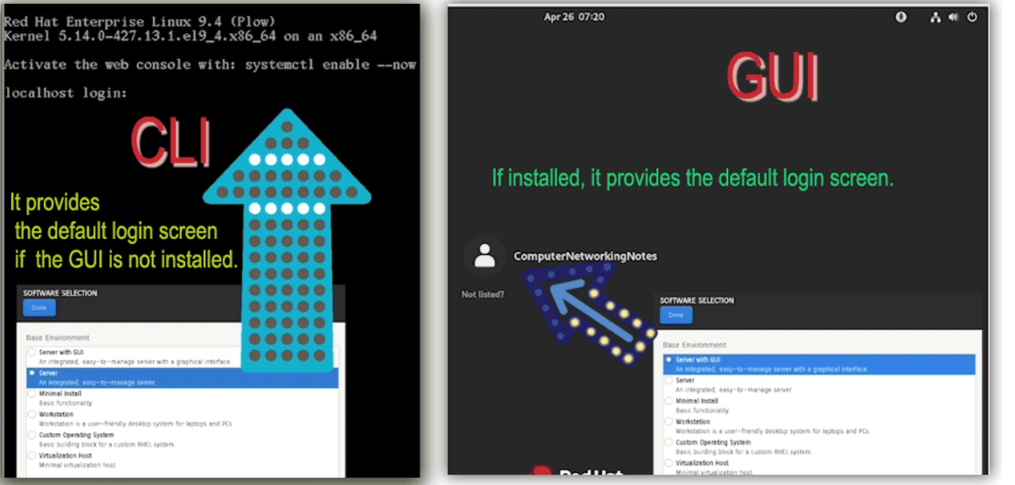
Finally, it shows the login screen — either a CLI login prompt or a GUI login manager (GDM).

In short:

“System services, targets, and login begin to load” means systemd is starting all the programs and preparing your system for you to log in.

🧩 Step 4: initramfs (Initial RAM Filesystem)
When the kernel executes /init inside the initramfs, here’s what happens:
1️⃣ Hardware drivers are loaded
- The initramfs environment contains essential kernel modules (drivers for disks, LVM, RAID, filesystems, etc.).
- These are loaded so the system can “see” the real disks.
2️⃣ Root filesystem is detected
- The /init script reads boot parameters like root=/dev/mapper/rhel-root to know where the real root partition is.
- It might activate LVM volumes (lvm vgchange -ay) or decrypt disks if necessary.
3️⃣ Mounts the real root
- Once drivers are ready, it mounts that device (e.g., /dev/sda2) as /sysroot.
4️⃣ Switches root (switch_root or pivot_root)
- This replaces the temporary RAM filesystem with the real disk-based root filesystem.
- After that point, everything runs from the actual storage, not from RAM.
5️⃣ Executes /sbin/init (→ systemd)
- Control now passes to systemd (PID 1) from the real root filesystem.

🧠 Summary:
initramfs is a temporary Linux mini-system in RAM that prepares hardware and mounts your real root filesystem before the main OS starts.

⚙️ Step 5: systemd Initialization (PID 1)
Once initramfs has mounted the real root filesystem and handed control to /sbin/init (which points to systemd in RHEL 9), systemd becomes process ID 1 (PID 1) — the first user-space process.
Here’s what happens inside this step:
1️⃣ systemd reads its configuration:
- From /etc/systemd/system/ and /usr/lib/systemd/system/.
- It figures out the default target (like graphical.target or multi-user.target) by reading /etc/systemd/system/default.target.
2️⃣ Mounts all filesystems:
- Using entries in /etc/fstab to mount /boot, /home, swap, etc.
3️⃣ Starts essential services (units):
- Examples: systemd-udevd, network, sshd, firewalld, chronyd, etc.
- These are managed as systemd units (service, socket, mount, device, etc.).
4️⃣ Switches to the default target:
- multi-user.target → command-line (non-GUI mode)
- graphical.target → GUI mode (loads GDM, the graphical login manager)
5️⃣ Reaches login prompt:
- CLI → getty provides the login: prompt.
- GUI → GDM shows a graphical login window.

🧠 In short:
systemd is the brains of the user-space startup — it brings the system from kernel-only mode to a fully working multi-user or graphical environment.

🧍‍♂️ Step 6: Login and Shell Initialization

Once systemd finishes starting all targets and services, it prepares your system for user interaction — the final stage of boot.
Here’s what happens:
1️⃣ Login prompt appears:
- If the default target = multi-user.target, you see a text login on the terminal (TTY).
- If the default target = graphical.target, you get a GUI login screen (like GDM).
2️⃣ User logs in:
- You type your username + password.
- The system verifies credentials using the PAM (Pluggable Authentication Modules) system.
3️⃣ Shell starts:
- After authentication, your login shell (e.g. bash, zsh, etc.) launches.
- It reads your startup files (/etc/profile, ~/.bash_profile, ~/.bashrc) to set environment variables, aliases, and paths.
4️⃣ User session begins:
- Now you can run commands, start applications, and interact with the fully booted Linux system.

🧠 So the full chain is:
BIOS/UEFI → GRUB2 → Kernel → initramfs (/init) → switch_root → systemd (PID 1) → login → shell

